**Range Composite**

* Adding Partitions

CREATE TABLE range_part

(

LNG_ID NUMBER,

LNG_3C_CODE CHAR(20),

LNG_2B_CODE VARCHAR2(3),

LNG_SCOPE_ID NUMBER,

LNG_TYPE_ID NUMBER,

LNG_DESC CHAR(200)

)

PARTITION BY RANGE (LNG_TYPE_ID)

(

PARTITION part_1 VALUES LESS THAN (2),

PARTITION part_2 VALUES LESS THAN (3),

PARTITION part_3 VALUES LESS THAN (5),

PARTITION part_4 VALUES LESS THAN (7)

);

--SELECT DISTINCT LNG_TYPE_ID FROM U_DW_REFERENCES.t_languages;

--DROP TABLE range_part;

INSERT INTO range_part

SELECT

LNG_ID,LNG_3C_CODE ,LNG_2B_CODE ,

LNG_SCOPE_ID,LNG_TYPE_ID,LNG_DESC

FROM U_DW_REFERENCES.t_languages

WHERE rownum < 200;

COMMIT;

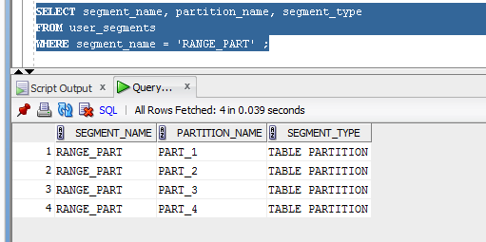

* Moving Partitions

CREATE TABLESPACE test1;

ALTER TABLE range_part MOVE PARTITION part_1

TABLESPACE test1 NOLOGGING;

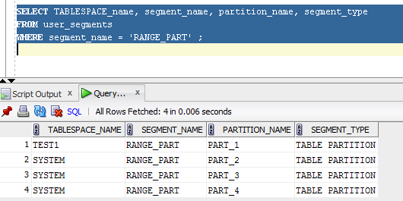

* Splitting Partitions

ALTER TABLE range_part SPLIT PARTITION

part_1 at (1) INTO

( PARTITION part_1A,

PARTITION part_1B);

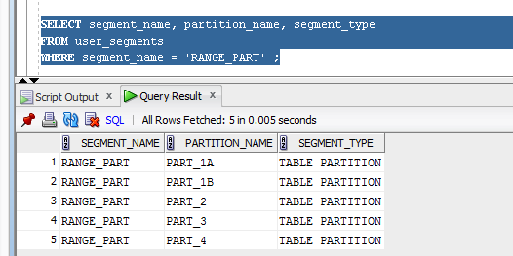

* Merging Partitions

ALTER TABLE range_part MERGE PARTITIONS

part_1, part_2

INTO PARTITION part_1A

UPDATE INDEXES;

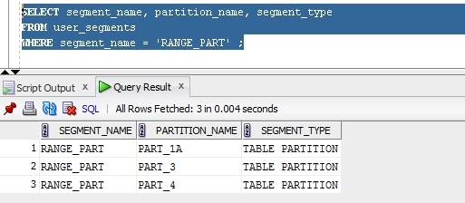

* Dropping Partitions

ALTER TABLE RANGE_PART DROP PARTITION PART_1A

UPDATE INDEXES;

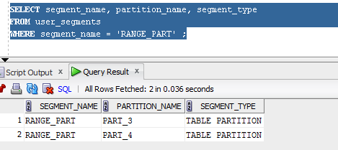

* Truncating Partitions

ALTER TABLE RANGE_PART TRUNCATE PARTITION PART_4;

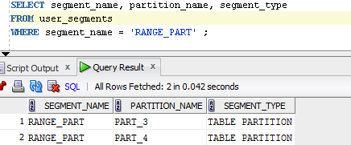

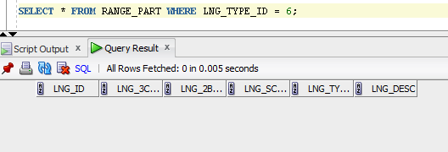

**HASH**

* Adding Partitions

CREATE TABLE hash_part

(

LNG_ID NUMBER,

LNG_3C_CODE CHAR(20),

LNG_2B_CODE VARCHAR2(3),

LNG_SCOPE_ID NUMBER,

LNG_TYPE_ID NUMBER,

LNG_DESC CHAR(200)

)

PARTITION BY HASH (LNG_TYPE_ID)

(

partition part_1 tablespace TS_PART_1,

partition part_2 tablespace TS_PART_2,

partition part_3 tablespace TS_PART_3,

partition part_4 tablespace TS_PART_4

);

--SELECT DISTINCT LNG_TYPE_ID FROM U_DW_REFERENCES.t_languages;

--DROP TABLE hash_part;

INSERT INTO hash_part

SELECT

LNG_ID,LNG_3C_CODE ,LNG_2B_CODE ,

LNG_SCOPE_ID,LNG_TYPE_ID,LNG_DESC

FROM U_DW_REFERENCES.t_languages

WHERE rownum < 200;

COMMIT;

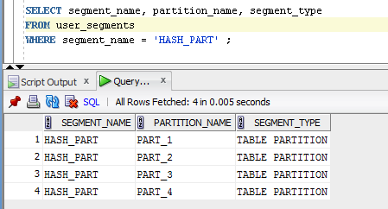

* Coalescing Partitions

ALTER TABLE hash_part COALESCE PARTITION;

